University Of Engineering and Technology, Lahore
Computer Engineering Department

Course Name: PF | Course Code: CMPE-112L
Assignment Type: Lab | Dated: 23 March,2026
Semester: 1 | Session: Spring 2026
Lab/Project/Assignment #: 4 | CLOs to be covered: CLO
Lab Title: Nested Loop | Teacher Name: Hafiz Muhammad Mubashar
Lab Evaluation:

CLO1 | Apply appropriate programming techniques to create executable programs to solve well defined problems
 | Level1 | Level2 | Level3 | Level4 | Level5 | Level6
(5)
Total |  |  |  |  |  | /5
Rubrics for Current Lab Evaluation
Scale | Marks | Level | Rubric
Excellent | 5 | L1 | Submitted all lab tasks, BONUS task, have good understanding.
Very Good | 4 | L2 | Submitted the lab tasks but have good understanding
Good | 3 | L3 | Submitted the lab tasks but have weak understanding.
Basic | 2 | L4 | Submitted the lab tasks but have no understanding.
Barely Acceptable | 1 | L5 | Submitted only one lab task.
Not Acceptable | 0 | L6 | Did not attempt
LAB No 4
Lab Goals/Objectives:
• Understand the concept of loops inside loops.
• Learn how nested loops work.
• Use nested loops for complex problems.
• Generate patterns and multi-dimensional outputs.

Equipment Required:
• Computer/Laptop
• Python IDE
• Python Interpreter

Theory:
A nested loop is created when one loop is written inside another loop. During execution, the inner loop runs from start to finish each time the outer loop completes one iteration.
Nested loops are especially useful for tasks such as:
- Creating different types of number and star patterns.
- Processing information arranged in rows and columns.
- Performing calculations on matrices.
- Solving problems that involve repeated actions at more than one level.

Lab Work:

Task 1
Write a python program to print a centered pyramid pattern using nested while loop.

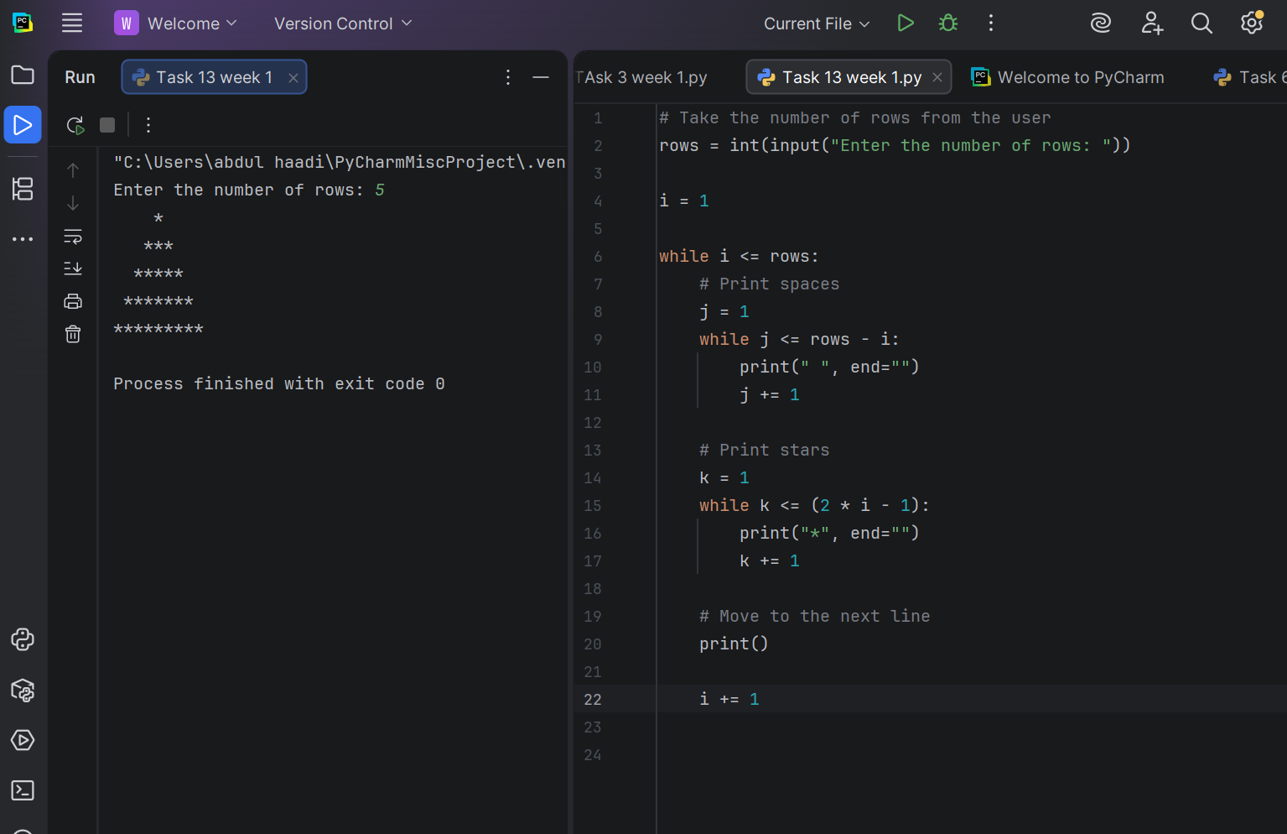

Task 2
Write a python program to print a left aligned right aligned triangle of stars using nested for loop.

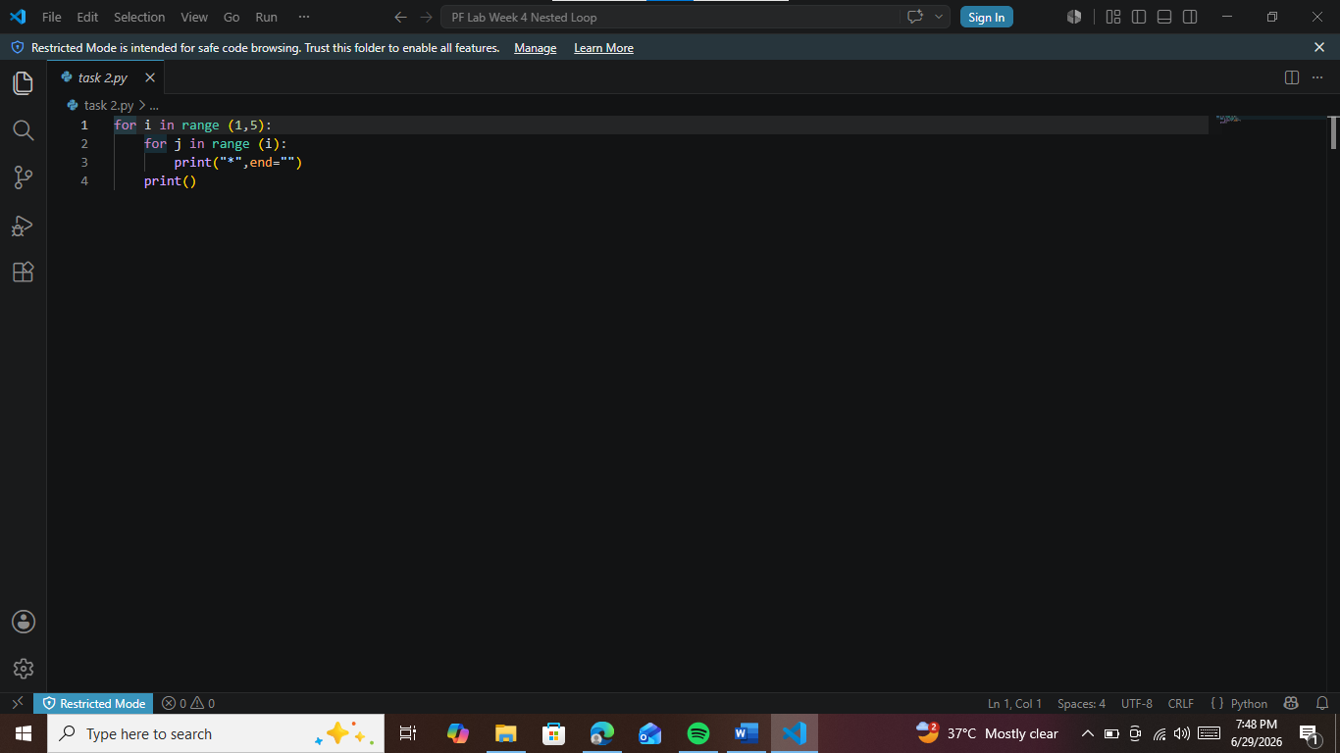

Task 3
Write a python program to print a eft aligned right aligned triangle of stars using nested gor loop.

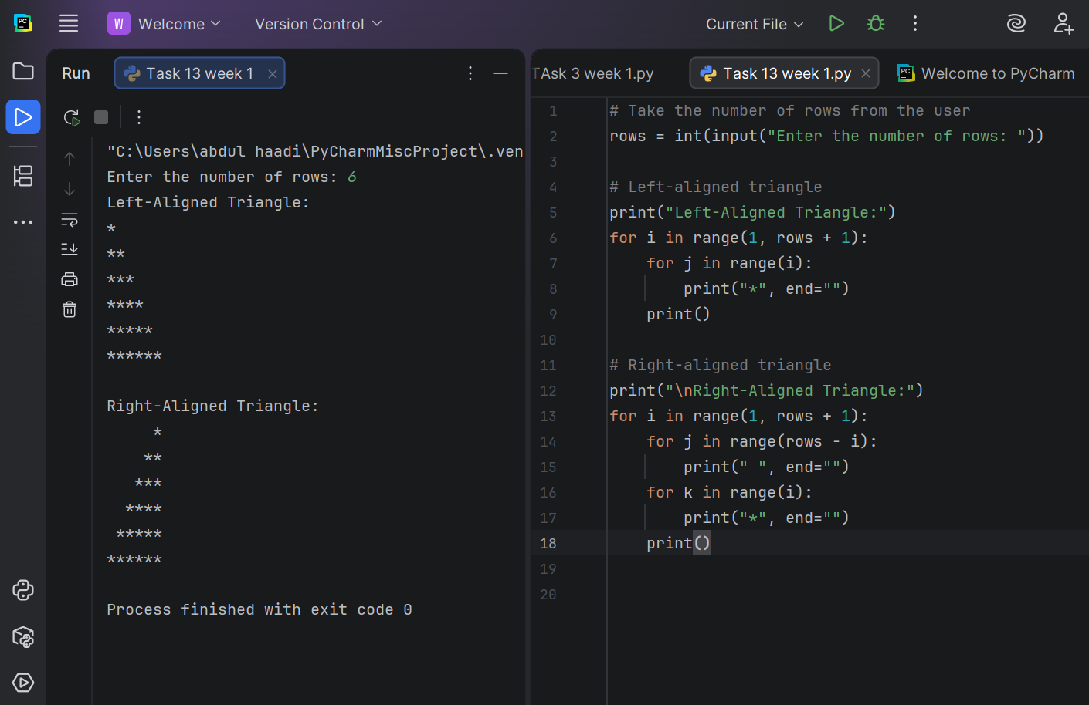

Task 4
Write a python program using nested for loop to display how the outer and inner loop counters change.

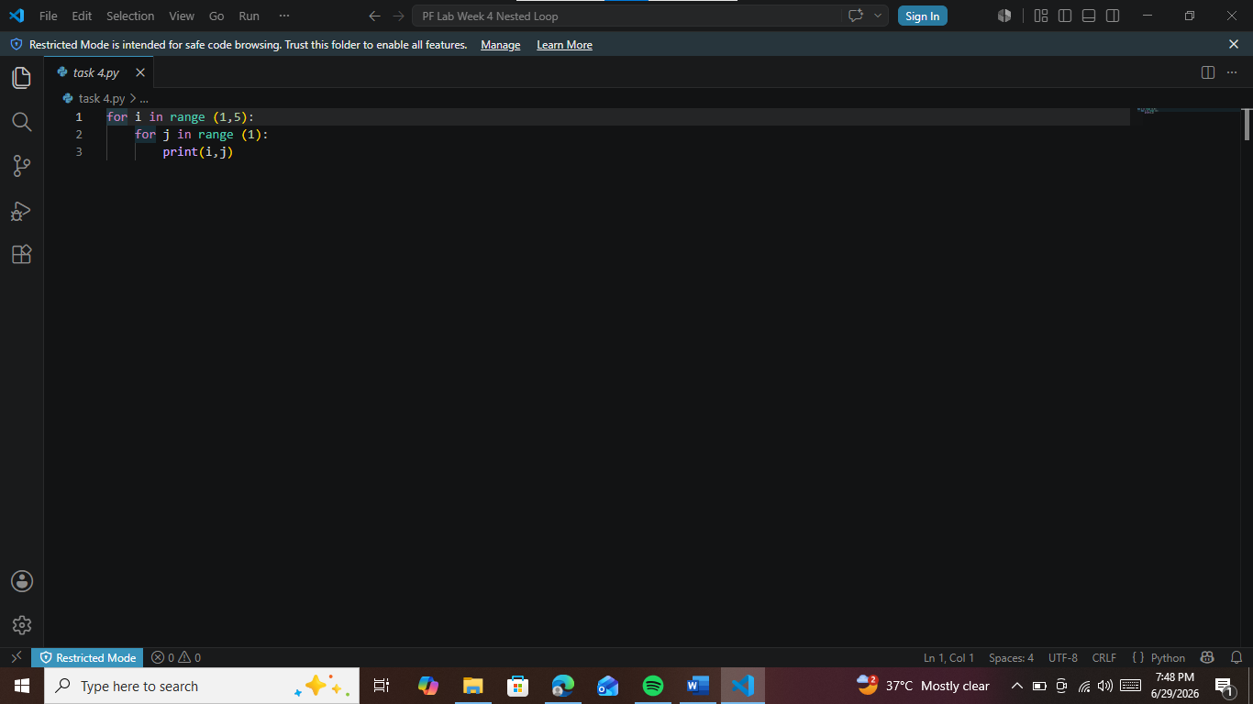

Task 5
Write a python program to print a number pattern where each row prints the row number multiple time using nested for loop.
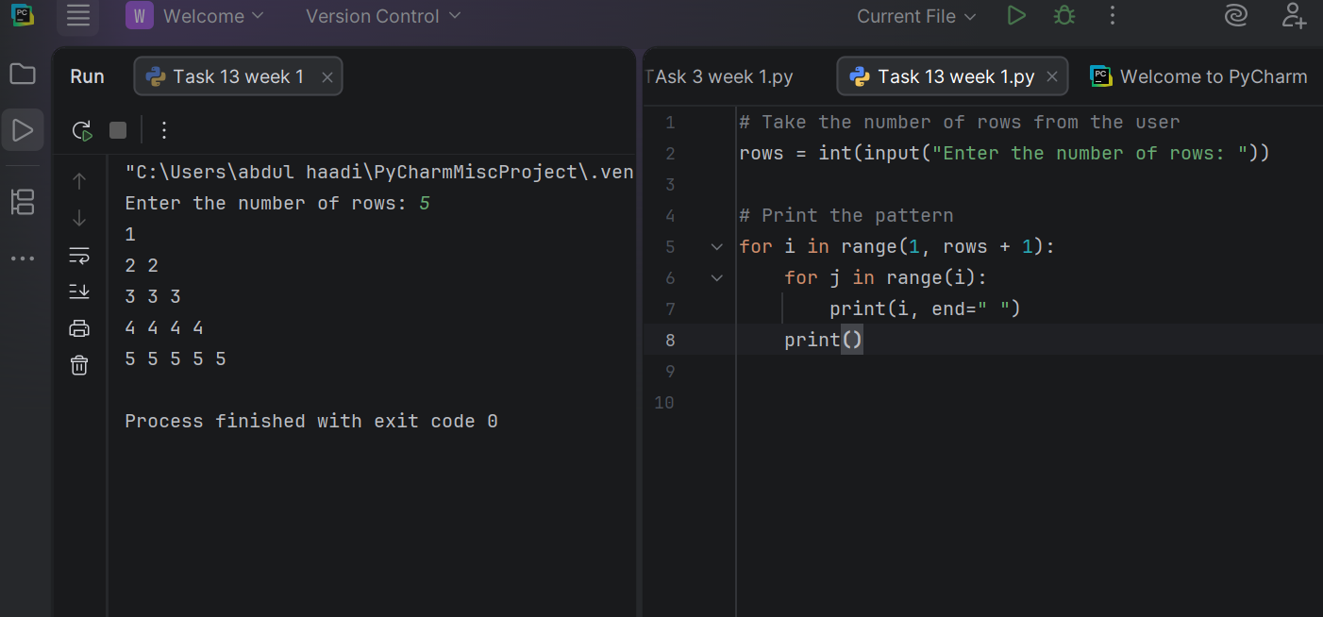
Task 6
Write a python program to coordinate pairs (i,j) in a triangular pattern .

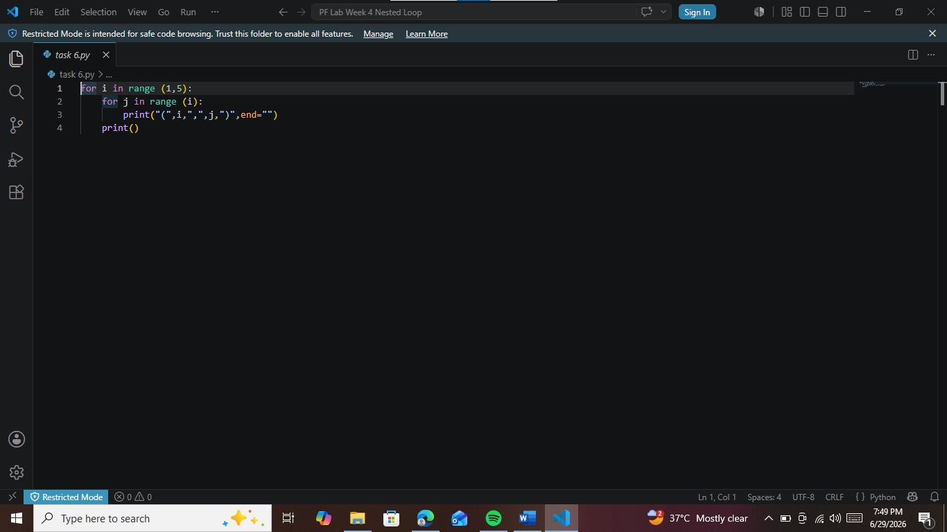

Task 7
Write a python program to print a pattern with decreasing 1 and increasing in each row using nested for loop.

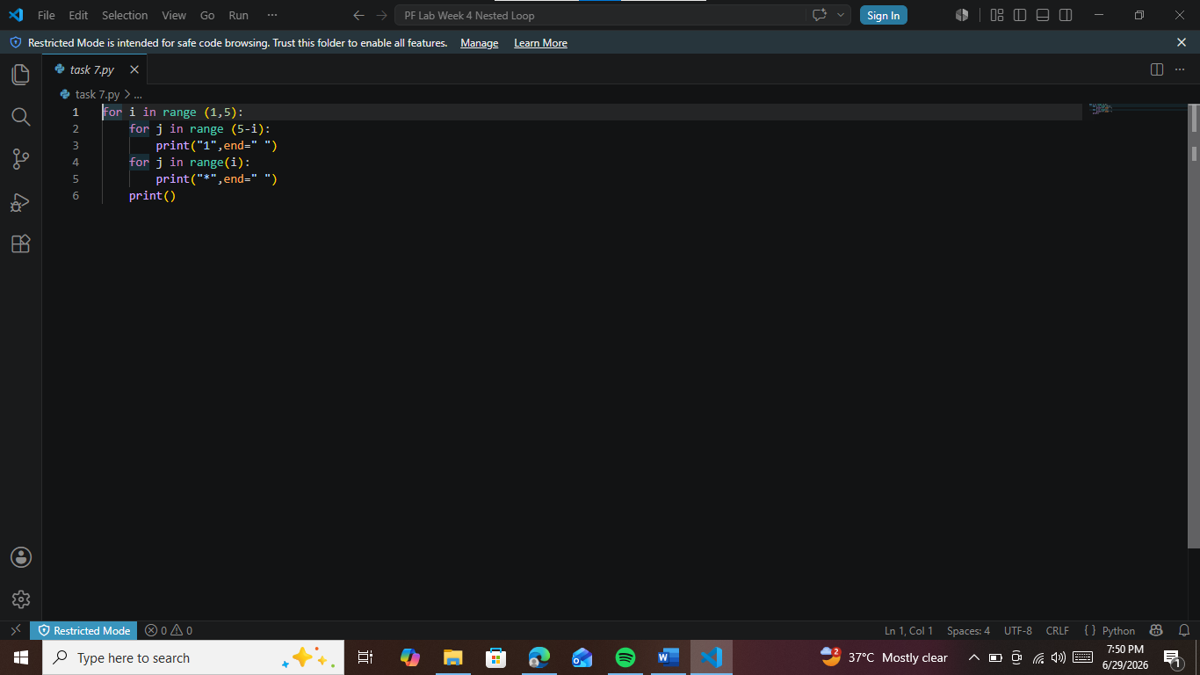
Task 8
Write a python program to print a centered pyramid of stars using nested for loop.

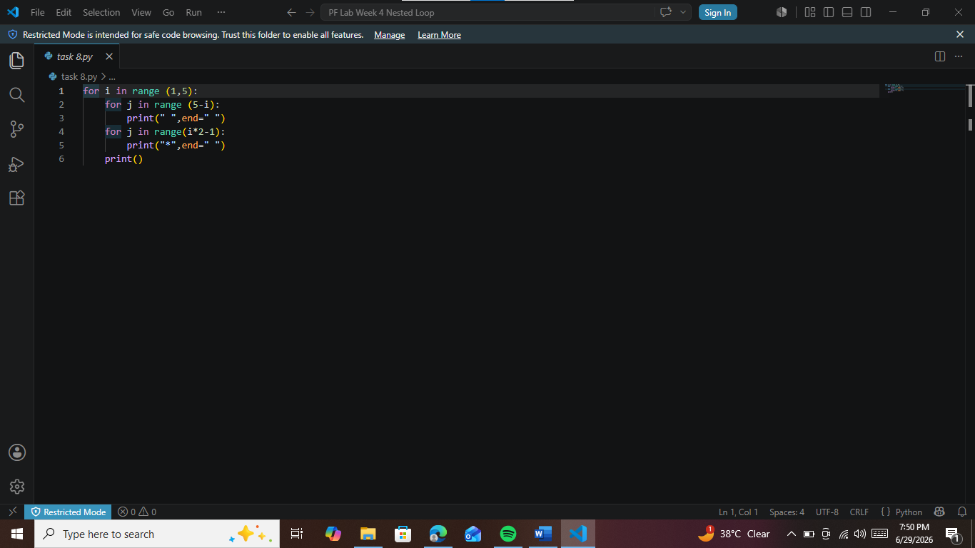

Task 9
Write a python program to print a centered pyramid of stars using nested while loop.

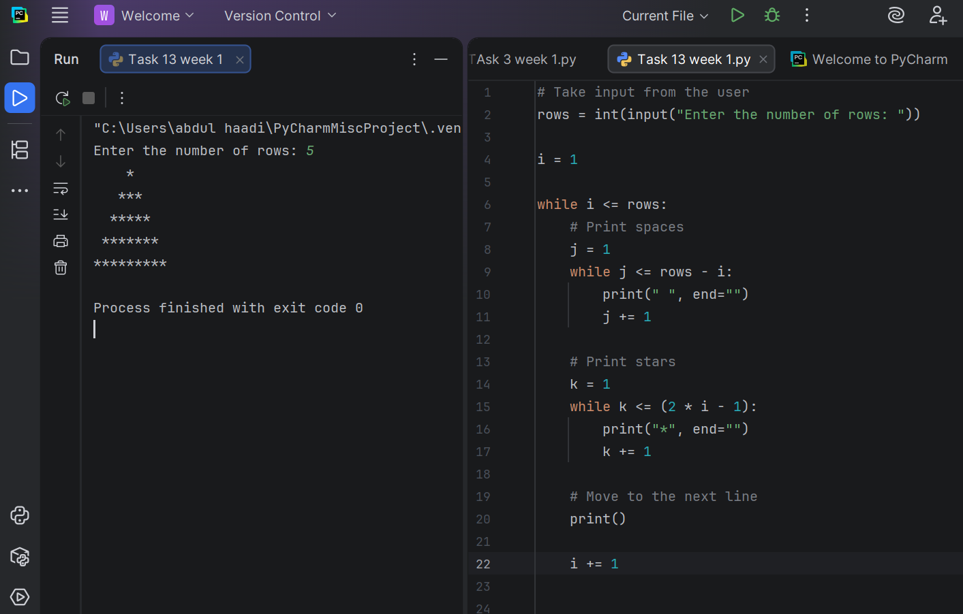

Conclusions:
In this lab, we explored the concept of nested loops in Python, where one loop is placed inside another to perform repeated tasks. We observed that the inner loop executes completely every time the outer loop runs once.
We practiced using nested loops to create different patterns and solve problems that require multiple levels of repetition. This approach is also helpful when working with rows and columns, tables, and other structured data.
Overall, this lab improved our understanding of loop control and strengthened our logical thinking. Learning nested loops enables us to write more efficient programs for tasks that involve repetitive operations within other repetitive operations.

